# MADANAPALLE INSTITUTE OF TECHNOLOGY AND SCIENCE

**Industrial Internship Report on**

**”Social Media Strategies for Online Shopping cart”**

**Prepared by**

**PATNAM GNANA ABYUDH SAI**

|  |
| --- |
| *Executive Summary* |
| This report provides details of the Industrial Internship provided by upskill Campus and The IoT Academy in collaboration with Industrial Partner UniConverge Technologies Pvt Ltd (UCT).  This internship was focused on a project/problem statement provided by UCT. We had to finish the project including the report in 6 weeks’ time.  My project was to include social media strategies in order increase the profits of a business.  This internship gave me a very good opportunity to get exposure to Industrial problems and design/implement solution for that. It was an overall great experience to have this internship. |

**TABLE OF CONTENTS**

1 Preface 3

2 Introduction 4

2.1 About UniConverge Technologies Pvt Ltd 4

2.2 About upskill Campus 8

2.3 Objective 9

2.4 Reference 9

2.5 Glossary 10

3 Problem Statement 11

4 Existing and Proposed solution 12

5 Proposed Design/ Model 13

5.1 High Level Diagram (if applicable) 13

5.2 FLowchart………………………………………………………………………………………………………………………………………14

6.Performance Test…………………………………………………………………………………………………………………………………15

6.1 Test plan………………………………………………………………………………………………………………………………………..15

6.2 Test Procedure……………………………………………………………………………………………………………………………..15

6.3 Performance outcome………………………………………………………………………………………………………………….15

7.My learnings………………………………………………………………………………………………………………………………………..16

# Preface

I am currently pursuing 2nd year degree in Bachelor of technology and sciences.

I chose to do this internship as a part of my 4th sem.

This internship is very good to learn new things.

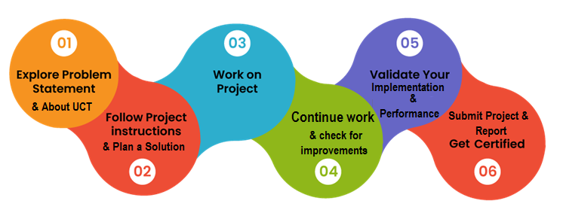

I feel this internship is very much organized.

Unlike the other internships this doesn’t made us lazy by just providing videos.

The upskills campus made us to efficiently work on the internship.

We have gone through the videos and e-books provided and I personally learnt many new strategies from the course.

We have also submitted the weekly reports as a part of weekly progress.

I would like to thank my friends for suggesting upskills for doing internship. I can even assure to my juniors that this is one of the best platforms for doing internships.

# Introduction

## About UniConverge Technologies Pvt Ltd

A company established in 2013 and working in Digital Transformation domain and providing Industrial solutions with prime focus on sustainability and RoI.

For developing its products and solutions it is leveraging various**Cutting Edge Technologies e.g. Internet of Things (IoT), Cyber Security, Cloud computing (AWS, Azure), Machine Learning, Communication Technologies (4G/5G/LoRaWAN), Java Full Stack, Python, Front end**etc.

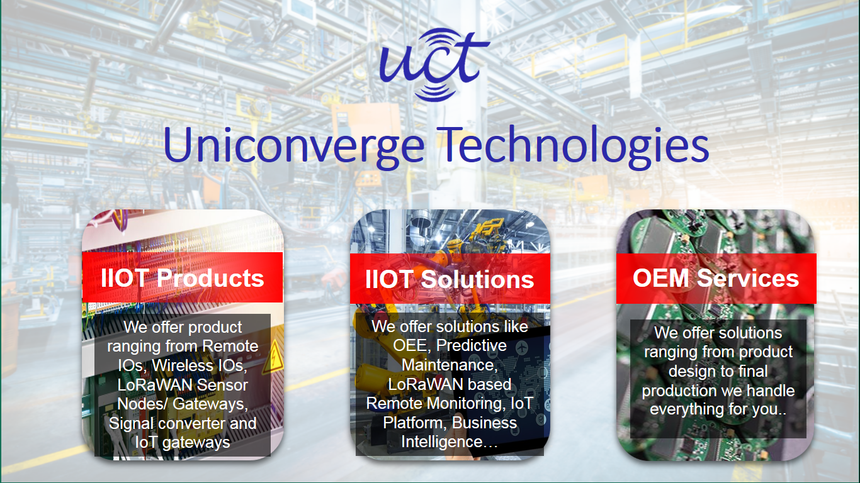

1. UCT IoT Platform **(****)**

**UCT Insight** is an IOT platform designed for quick deployment of IOT applications on the same time providing valuable “insight” for your process/business. It has been built in Java for backend and ReactJS for Front end. It has support for MySQL and various NoSql Databases.

* It enables device connectivity via industry standard IoT protocols - MQTT, CoAP, HTTP, Modbus TCP, OPC UA
* It supports both cloud and on-premises deployments.

It has features to  
• Build Your own dashboard  
• Analytics and Reporting  
• Alert and Notification  
• Integration with third party application(Power BI, SAP, ERP)  
• Rule Engine

 

1. **Smart Factory Platform (****)**

Factory watch is a platform for smart factory needs.

It provides Users/ Factory

* with a scalable solution for their Production and asset monitoring
* OEE and predictive maintenance solution scaling up to digital twin for your assets.
* to unleased the true potential of the data that their machines are generating and helps to identify the KPIs and also improve them.
* A modular architecture that allows users to choose the service that they what to start and then can scale to more complex solutions as per their demands.

Its unique SaaS model helps users to save time, cost and money.

 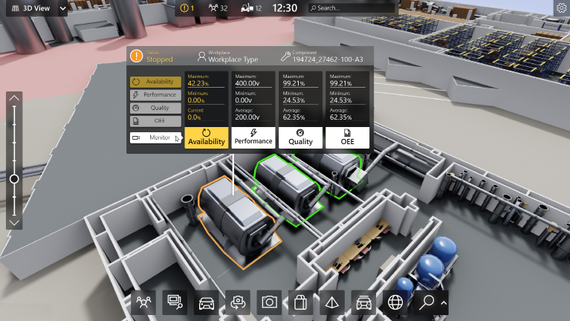

1. 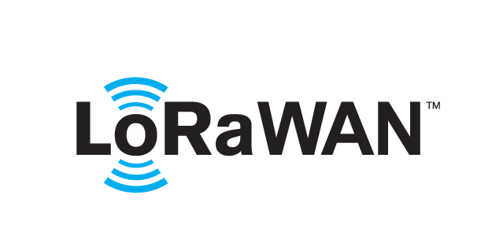 based Solution

UCT is one of the early adopters of LoRAWAN teschnology and providing solution in Agritech, Smart cities, Industrial Monitoring, Smart Street Light, Smart Water/ Gas/ Electricity metering solutions etc.

1. Predictive Maintenance

UCT is providing Industrial Machine health monitoring and Predictive maintenance solution leveraging Embedded system, Industrial IoT and Machine Learning Technologies by finding Remaining useful life time of various Machines used in production process.



## About upskill Campus (USC)

upskill Campus along with The IoT Academy and in association with Uniconverge technologies has facilitated the smooth execution of the complete internship process.

USC is a career development platform that delivers **personalized executive coaching** in a more affordable, scalable and measurable way.



Seeing need of upskilling in self paced manner along-with additional support services e.g. Internship, projects, interaction with Industry experts, Career growth Services

<https://www.upskillcampus.com/>

upSkill Campus aiming to upskill 1 million learners in next 5 year

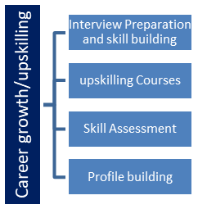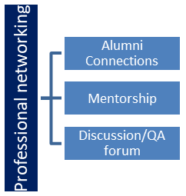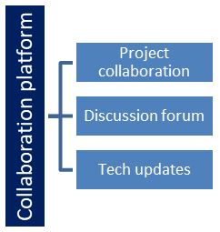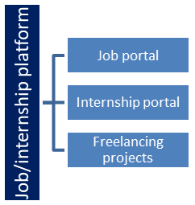

## The IoT Academy

The IoT academy is EdTech Division of UCT that is running long executive certification programs in collaboration with EICT Academy, IITK, IITR and IITG in multiple domains.

## Objectives of this Internship program

The objective for this internship program was to

 ☛ get practical experience of working in the industry.

 ☛ to solve real world problems.

 ☛ to have improved job prospects.

 ☛ to have Improved understanding of our field and its applications.

 ☛ to have Personal growth like better communication and problem solving.

## Reference

[1] Google

[2] Newspaper

[3] YouTube

## Glossary

|  |  |
| --- | --- |
| Terms | Acronym |
| Assumptions | Those events and circumstances that are expected to occur during the project life-cycle |
| Baseline | A fixed reference point that can be used as a comparison |
| Benefits | The gains of the business which are achieved by doing the project |
| Communication plan | This describes how the project’s stakeholders and interested parties will be kept Informed during the project |
| Critical path | The critical path is the longest path in a project schedule network diagram . |

# Problem Statement

Over the past quarter century there has been a shift from the traditional way of marketing to a new electronic age. Speaking about social media as a platform for e-commerce, It is clear that social media is used daily and awareness was high. This reduced operating costs for firms in establishing and maintaining customer relationship. This information is likely to impact the marketing strategy of companies to customers and suppliers.

By this project we are going to tell about better social media strategies for an online cart .

# Existing and Proposed solution

Existing strategies are:

1.setting up goals

2.know the customer content preference

New Strategies:

1.Focusing on sharing rather than selling.

2.Social Media post Optimization

3.Share the right content

4.Start with a blog

## Code submission (Github link)

https://github.com/PATNAMGNANASAI/PROJECT-IN-DIGITAL

# Proposed Design/ Model

We have designed a shopping website to ensure that it attracts customer.

## High Level Diagram (if applicable)

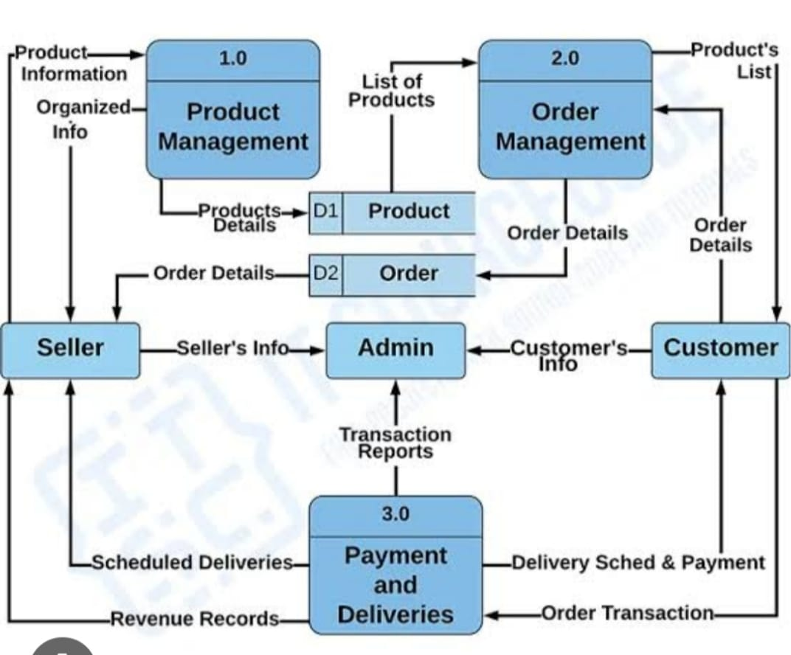

Figure 1: HIGH LEVEL DIAGRAM OF THE SYSTEM

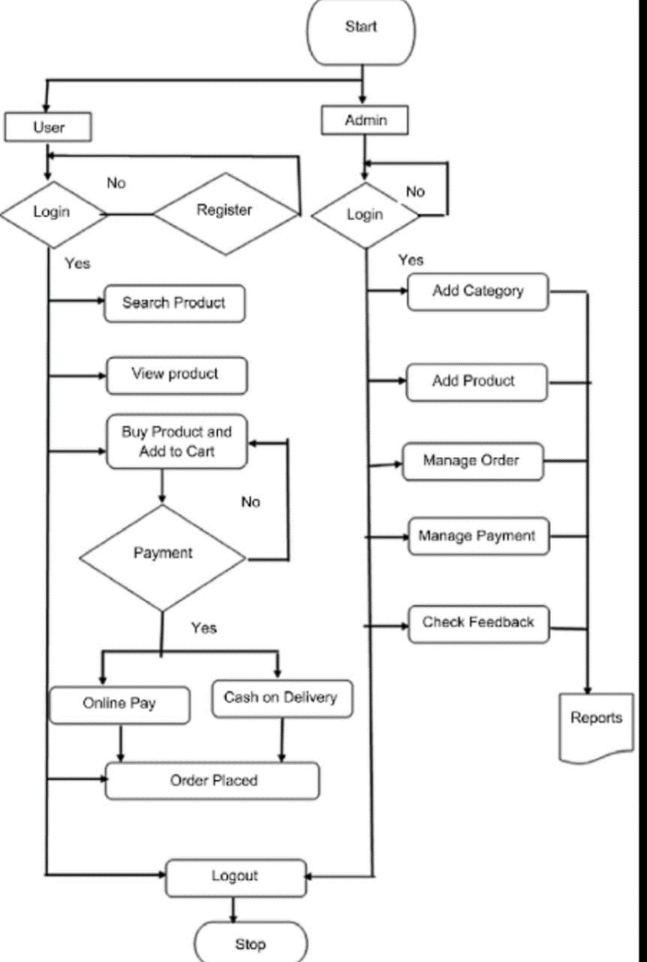

# Performance Test

Performance testing is a non functional software testing type .it is used to test the stability and response time of an application by applying and desired loads.

## Test Plan/ Test Cases

CheckList:

* Test environment server specification must be same as production environment
* Ensure the architecture ,we need to hit the application ,server,and database layer to verify the performance.
* We need to very response time of the primary request only.

## Test Procedure/cases

TOOLS:

GTmetrix

Lighthouse

Google page speed

* The user should be able to navigate to all the pages in the website
* There should be a fallback page for any load errors
* Verify that all the links and banners work properly.

## Performance Outcome

Performance for the developed shopping cart passed all the constraints for the tests done.

# 7 My learnings

Before this internship I was very new to this domain of digital marketing .but I was always interested in digital marketing. So,I chose this internship to master in digital marketing.

I have gained much knowledge about digital marketing.

I have known the pros and cons of digital marketing.

I have learned about how to deal with a business.

This internship also helped me to know about my personality that how much work I can do.

# Finally I am very much thankful to upskills campus for providing this opportunity.